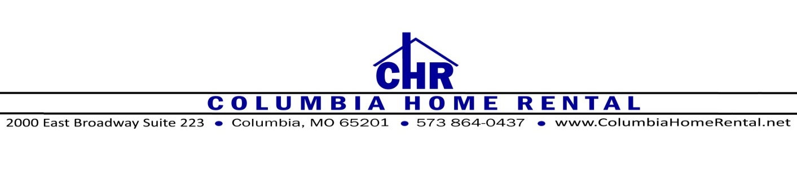

The property was provided to you clean and ready to occupy, and should, excluding normal wear and tear, be returned to us in the same condition per the terms of your written lease. This will also ensure a timely return of your Security Deposit. The following is a list of items to check when preparing to vacate the premises.

**FLOORING**

* If carpeted, they must be professionally cleaned and receipts must be provided. *You will need to schedule this at least 2 weeks in advance.*
* If hard flooring such as tile or vinyl, floors must be swept and mopped clean.
* If laminate flooring, floors must be swept and lightly mopped clean.

**KITCHEN**

* Appliances: Refrigerator and freezer should be emptied of all personal items. Shelves, doors, interior walls and exteriors (including TOP) should be wiped clean. Be sure to clean behind appliances as well.
* Stoves and microwaves should be cleaned both inside and out. The ‘self-cleaning’ function is acceptable for the oven - *do not use oven cleaner if you have a self-cleaning oven as this will damage the finish.*
* Drips pans should be replaced. Note that the stove top lifts up to allow for easier cleaning under the burners, unless you have a flat top stove.
* Cupboards & drawers should be completely emptied and wiped clean inside and out.
* Counters & sinks should be wiped clean.
* Run garbage disposal to be certain the drain is clear.
* Verify that all personal items are removed from the dishwasher and run an empty cycle with vinegar to clean and freshen the machine.

*Tip: Do not leave oven racks in during a self-clean cycle. Instead, wash them in a bathtub with mild detergent*

**BATHROOMS**

* Cupboards should be emptied and wiped clean inside and out.
* Sinks, mirrors, commodes, tubs and showers should be clean, including walls and floors of shower.
* To ensure your full deposit refund, replace the toilet seat if it is cracked, broken or stained.

*Tip: Vinegar works great to shine up faucets and appliances, also works well on mirrors.*

**LIVING SPACES**

* Empty all rooms & closets of personal items, remove all trash and debris.
* Be sure cold air returns are dusted and free of debris.

**LIGHTING FIXTURES & SMOKE DETECTORS**

* All lights must have working light bulbs.
* Any smoke or carbon monoxide detectors must have fresh batteries.
* Ceiling fan blades should be dusted.

*Tip: use a pillow case to dust ceiling fan blades, this catches all the dust as it wipes it off.*

**WINDOWS & DOORS**

* Windows must be closed and locked.
* Windows must be cleaned and sills dusted.
* Blinds should be clean and in working order.
* Windows must be closed and locked.
* Doors must be locked, and all working keys returned.

*Tip: To clean blinds, remove them and soak in the bathtub with a mild detergent. It is often easier to replace them than to clean them, contact the office for brand, color and size details to be certain they match the rest of the home.*

**WALLS**

* Walls should be wiped clean of any visible dirt.
* Baseboards should be wiped clean of dust and pet hair.

**EXTERIOR**

* All personal items, trash and debris must be removed from the premises.
* Cigarette butts must be removed from the grounds.
* Any animal debris or excrement must be removed.
* Decks must be free of trash and debris, and all personal items must be removed from beneath.

**LAUNDRY ROOM**

* Washer hose connection must be shut off fully.
* Dryer vent connection should be cleaned of any lint, dust or debris.
* Furnace filter should be replaced.

**GARAGE**

* All remotes must be returned.
* Remote entry keypad should have fresh batteries.
* All trash and debris should be removed, and floor swept out.

**UTILITIES**

* Please notify us as to the date you will turn off your power so that we can be sure it is switched over correctly.
* All Utility Bills must be paid in full.

This list may not be comprehensive for your home. It is a guideline to help you see the little details that will help you to avoid charges and delays regarding your security deposit. Please contact the office if you have any questions or concerns.

Additional steps to help you avoid delays and charges:

* Let the office know of any repairs or damages that will need to be addressed.
* Be sure you complete a forwarding address form with the office, so the check may be mailed to you directly without delays.
* Complete forwarding address card with the US Postal Service.
* Arrange to have utilities discontinued and notify office of date.
* Dispose of all trash and debris. Do not leave a pile of trash on the curb, unless your departure happens to coincide with the regular trash pick-up. The City of Columbia will do a special pick up if needed, for an extra fee.
* Return any equipment to cable or satellite company.
* Schedule a final walk through with the office. This is a great opportunity to return keys and remotes and verify your forwarding address.